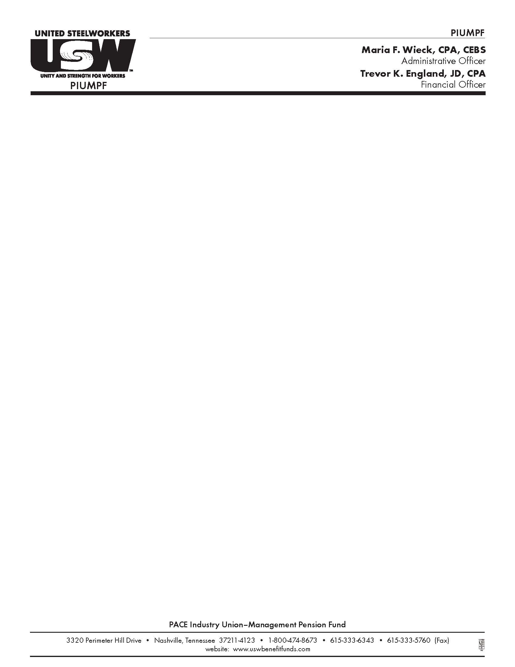

July 26, 2012

**Notice Regarding Death Benefit for Participants in the Retirement Fund for Local 299**

Dear Participant:

The Board of Trustees of the PACE Industry Union-Management Pension Fund (“Fund”) has adopted the following changes to the PACE Industry Union-Management Pension Plan (“Plan”). This letter summarizes the changes.

The Plan provides for a $1,000 lump sum death benefit for the beneficiary of a pensioner who retired under the Retirement Fund for Local 299 prior to September 1, 1984 and dies on or after October 16, 1984. However, as explained in the Fund’s Notice of Critical Status Certification sent on April 30, 2010, under federal law, the Fund is prohibited from paying a lump sum death benefit to beneficiaries of participants who die after the date the Notice was provided. This means that this death benefit will not be paid to beneficiaries of participants who die after April 30, 2010.

Sincerely,

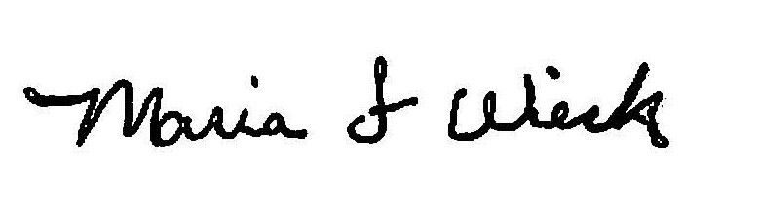

Maria Wieck

Administrative Officer